Academic Year: 2024-25 | Year: First Year | Term: I
Roll No.: | 11
Name: | Riddhee Sandeep Kulkarni
Subject: FCP
Assignment No.: | 17
Title: | Matrix subtraction
Date:

Contents
1. Theory (Logic) 2
2. Pseudo Code 2
3. Program Code 2
4. Output 2
5. Conclusion 2

THEORY:

In this code, we will subtract two matrices and print the resultant matrix. Declare 3 arrays

m1[3][3]={{2,4,6}{8,10,12}{14,16,18}}, m2[3][3]={{1,2,3}{4,5,6}{7,8,9}}, m3[3][3] and 2

integer variables i,j. To print the given matrix, create a for loop with i=0,i<3,i++, then create

another for loop in it with j=0,j<3,j++, and then add the print statement. Follow the same

steps to print the 2nd matrix m2. Create 2 same for loops, inside the 2nd loop write

m3[i][j]=m1[i][j]-m2[i][j]. This way, we will get the 3rd matrix m3. To print it again, follow

the same procedure as done to print matrix m1 and m2.

PSEUDO CODE:

Step 1: Start

Step 2: variable and array declaration

Step 3: printing matrices m1 and m2

Step 4 : subtract m1 and m2

Step 5: print resultant matrix m3

Step 6: end

PROGRAM CODE:

#include <stdio.h>

int main()

{

int m1[3][3]= {{2,4,6},{8,10,12},{14,16,18}},m2[3][3]= {{1,2,3},{4,5,6},{7,8,9}};

int i,j,m3[3][3];

printf("the fist matrix is:\n");

for (i = 0; i < 3; i++)

{

for (j = 0; j < 3; j++)

{

printf("%d ", m1[i][j]);

}

printf("\n");

}

printf("the second matrix is:\n");

for (i = 0; i < 3; i++)

{

for (j = 0; j < 3; j++)

{

printf("%d ", m2[i][j]);

}

printf("\n");

}

for (i = 0; i < 3; i++)

{

for (j = 0; j < 3; j++)

{

m3[i][j] = m1[i][j] - m2[i][j];

}

}

printf("The subtraction of the two matrices is: \n");

for (i = 0; i < 3; i++)

{

for (j = 0; j < 3; j++)

{

printf("%d ", m3[i][j]);

}

printf("\n");

}

}

OUTPUT:

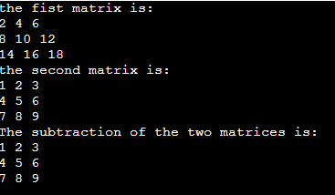

CONCULSION:

Code is run successfully, required output received

